
LIMITED
LIABILITY COMPANY
LASERTAG

SPECIFICATION

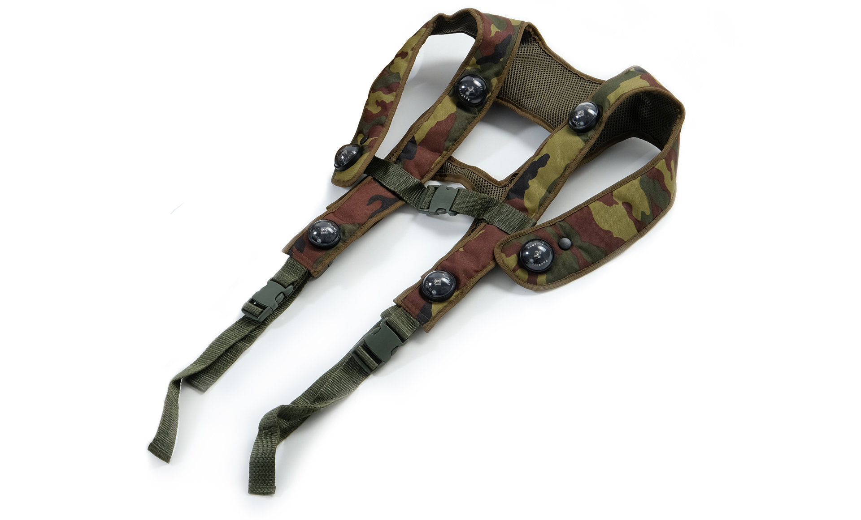

Game set
RGB hostage Pro

Smolensk

- Contact information
Official website:
www.laserwar.ru

E-mail:
info@laserwar.ru
support@laserwar.ru

Skype:
info-laserwar.ru
support laserwar.ru


_____________________
Stamp signature

2. Batteries. The device uses a 2.2 Ah li-polymer battery. To recharge the device use only universal Li+ chargers.
First of all, connect the charger to the device, and only then to the network.
You can control the recharge process with the help of a special indicator. If the battery is low, the LED is red; When the recharge process is complete, the color will be changed to green.
Please note! The vest must be recharged immediately after you have played with it under constant supervision at temperature no less than 0°С and no longer than for 2 hours.

- Guarantee commitment
The manufacturer guarantees the reliability of the operation of an individual LASERWAR set if the consumer has complied with the conditions of use. The manufacturer undertakes to replace or repair an individual set of equipment free of charge, if the customer has complied with the rules for the device transportation, storage, operation and delivery of defective equipment to Smolensk City.
The warranty is 14 days for batteries, speakers, and IR modules.
PLEASE NOTE! In the case of improper operation of the accumulator (charging by an unrelated type of a charger), the warranty doesn't cover the battery! You can see on our website a complete technical maintenance manual for Lasertag equipment: www.cybertag.ru.

6
7

Purchase Date: _______________
- Description and work
  - Device
The RGB hostage Pro game set is a strap of solid waterproof polyester material. A special hygienic cloth is used in its production. Six hit sensors provide a 360-degree horizontal and 180-degree vertical hit zone.
The control units are located in the back part of the vest. The vest with 8 hit sensors is shown on the diagram:

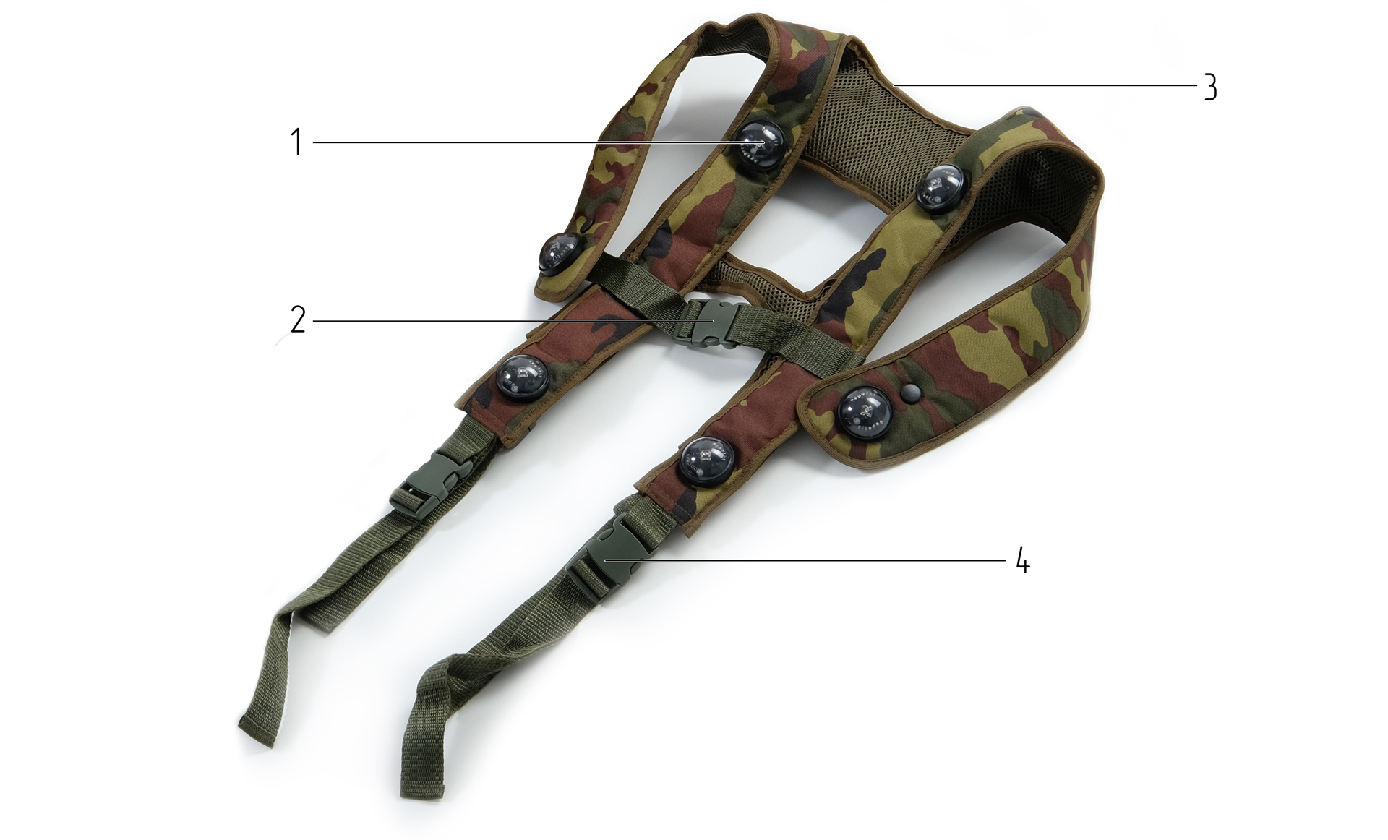

1. TSOP Sensors (sensors)
2. Fastex fastener
3. Control Unit
4. Adjustable straps

Information on the repairs performed during the maintenance period (completed by the Service centre performing the warranty repair works).

Date: __________________  Completed work: _____________________________________________________________________  Service centre stamp | Date: __________________  Completed work: _____________________________________________________________________  Service centre stamp
Date: __________________  Completed work: _____________________________________________________________________  Service centre stamp | Date: __________________  Completed work: _____________________________________________________________________  Service centre stamp
Date: __________________  Completed work: _____________________________________________________________________  Service centre stamp | Date: __________________  Completed work: _____________________________________________________________________  Service centre stamp

3
10

  - Changing the performance characteristics
Use the Lasertag configurator program to change RGB hostage Pro settings. The following options can be edited. A number of hostage's health points, level of background illumination, friendly fire.

  - Pre-starting procedure

Use the tact switch located on the control unit to turn on the game set. The sensors will start blinking white. The game set is activated with the help of a LASERWAR remote control ("New Game" option) or a first aid kit. The bandage color will turn white. When shot at, the sensors' color will correspond to the gunner's color. The game set is ready to use. Now everything depends on the chosen scenario and chosen settings.

Warranty Terms:

1. The guarantee is effective upon presentation of the present certificate, which indicates the purchase date of the equipment confirmed by the service centre.
2. These guarantee obligations apply to products acquired only from the official LASERTAG representative or the official dealer.
3. The present guarantee is invalid if the product deficiencies have occurred in the following cases:
- failure to comply with Operating instructions;
- mechanical damage;
- penetration of extraneous items, liquids, etc.;
- animal activities;
- unauthorized access to the parts of the game set by non-authorized persons;
- use of the product for purposes for which it hasn't been made;
- Acts of elements (natural disaster, fire, accidents, etc.);
- the game set malfunction in case of faulty power network and/or poor care of the product.
4. If the warranty certificate is lost, no duplicate is issued.

4
9
- Operating rules
If the game set gets wet, it can result in the electronics failure. That's why the bandage should be dried.
In addition, during use of the vest, the device can experience mechanical damage to the caps that protect the sensors. In such cases, the caps must be replaced.
It is necessary to store the equipment in a well-ventilated space at temperature from + 18°C to + 30°C and relative humidity of 45-65%.
Store equipment only in charged state (ideally under nominal voltage conditions).
1. Weather conditions. We strongly recommend that the equipment shouldn't be used in the rain and at temperatures below -20°C. Avoid getting moisture inside the frame. If this happened, turn off the device, dry the equipment at room temperature for at least two hours.
Having used the device at low temperatures don't try to charge it immediately after the game. Wait for electronics to warm up.

Dear Customer!

Our company welcomes and thanks you for the decision to buy our products, and is confident that the purchased device will bring you a long-term pleasure. The warranty certificate establishes the guarantee of the product in the amount provided for by the Law on consumer protection of the Russian Federation.

This warranty certificate is valid for 12 months from the purchase date of the product, provided the guarantee terms are observed.

5
8
2
11
- The intent of the device
The RGB hostage Pro game set allows you to play hostage scenarios. The game set doesn't require a laser tag rifle.

- Technical Specifications
 | Wireless
Weight | 0.332 kg
Battery type | Li-polymer 2.2 Ah
Battery charger type | automatic, Li +
Battery life | up to 36 hours.

- Contents of delivery
№  Ser. No. | Name | Unit of Measure | Quantity
1. | RGB hostage Pro game set | pc. | 1
2. | Specification | pc. | 1

